|  |  |  |  |  |  |  |  |
| --- | --- | --- | --- | --- | --- | --- | --- |
| **Location** | **N. Sample** | **Prog** | | **Est** | | **Cort** | |
| Mean | Sd | Mean | Sd | Mean | Sd |
| **Mt Graham** | 44 | 133 | 192 | 149 | 158 | 67.6 | 50 |
| **White Mountains** | 47 | 159 | 144 | 378 | 595 | 173 | 203 |
| **Zoo** | 885 | 27 | 10.1 | 103 | 56.4 | 53.7 | 60.2 |

` 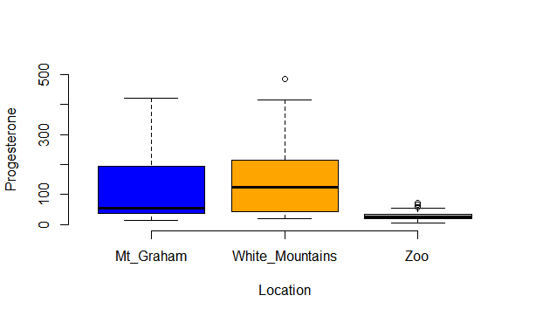

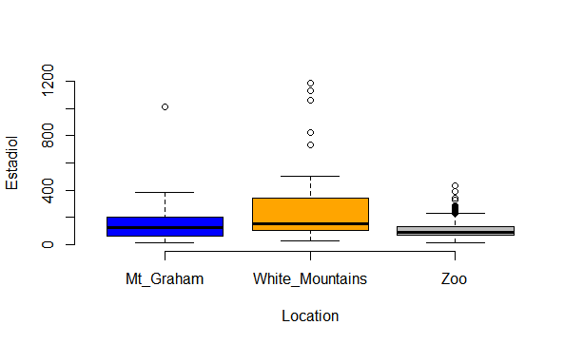

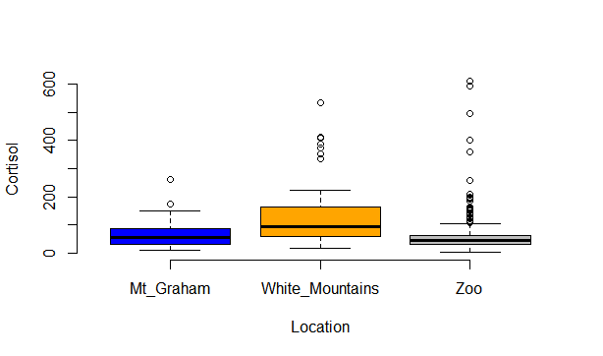

The following are the same graph, but they underline the mean and they have a 95% interval where the data are.

